**Bug report:**

Operating System: Windows

PHP Version: 8.2.14

Laravel Version: 10.40.0

Bug 1: Feature Bug

Summary: Cannot undergo Google verification.

Steps to reproduce:

1. Go to the server link.
2. Try to navigate ‘Google authentication’

Expected result: Successful verification while undergoing google authentication.

Actual result: No functionality to verify google authentication.

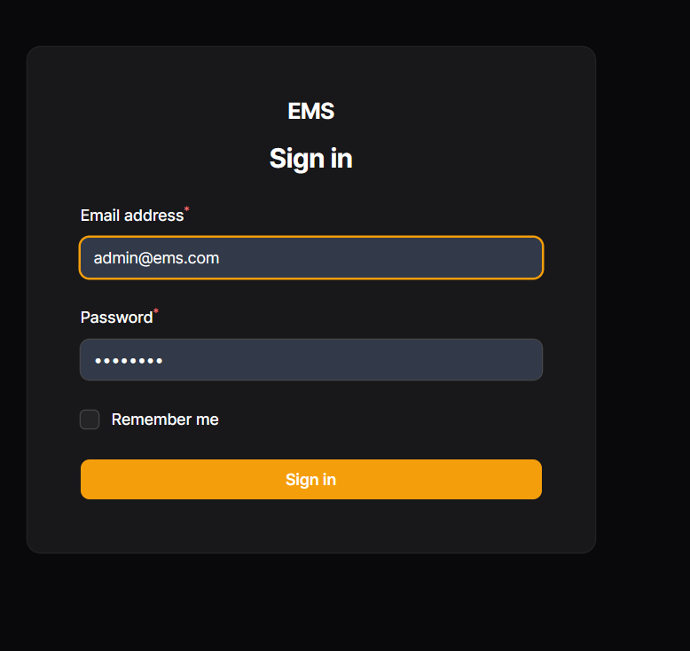

Figure 1: Feature bug

Bug 2: Functional bug

Summary: Cannot apply for leave or late request in the request page.

Steps to reproduce:

1. Go to the request page after being logged in.
2. Try to create a request for late/leave.
3. Click on create.

Expected result: Successful creation of request.

Actual result: Error in connection.

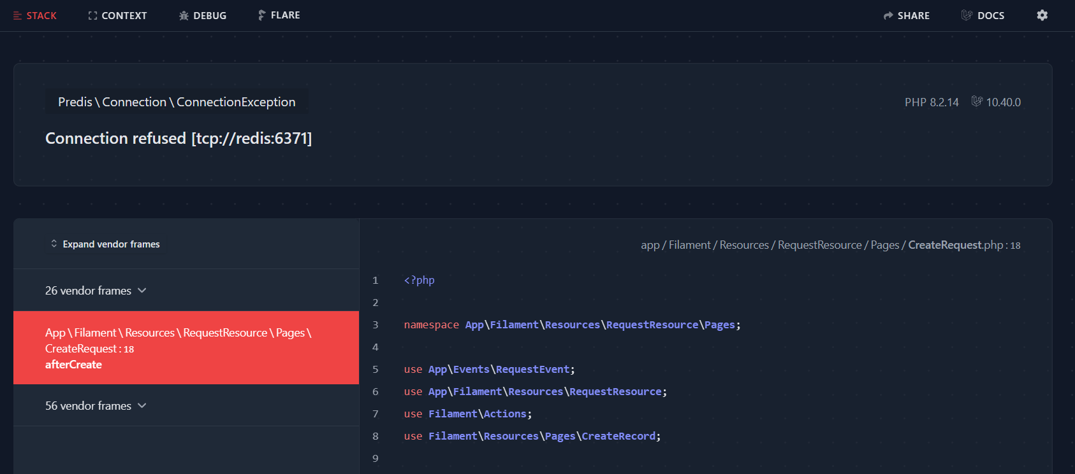

Figure 2: Functional Bug

Bug 3: Feature Bug

Summary: Does not send email notification to the head of department after a request is created .

Steps to reproduce:

1. Go to the request page as a user logged in as admin/super admin .
2. Try to navigate the notifications after creating request.

Expected result: Notification to the head of department for the request.

Actual result: No functionality to get notification.

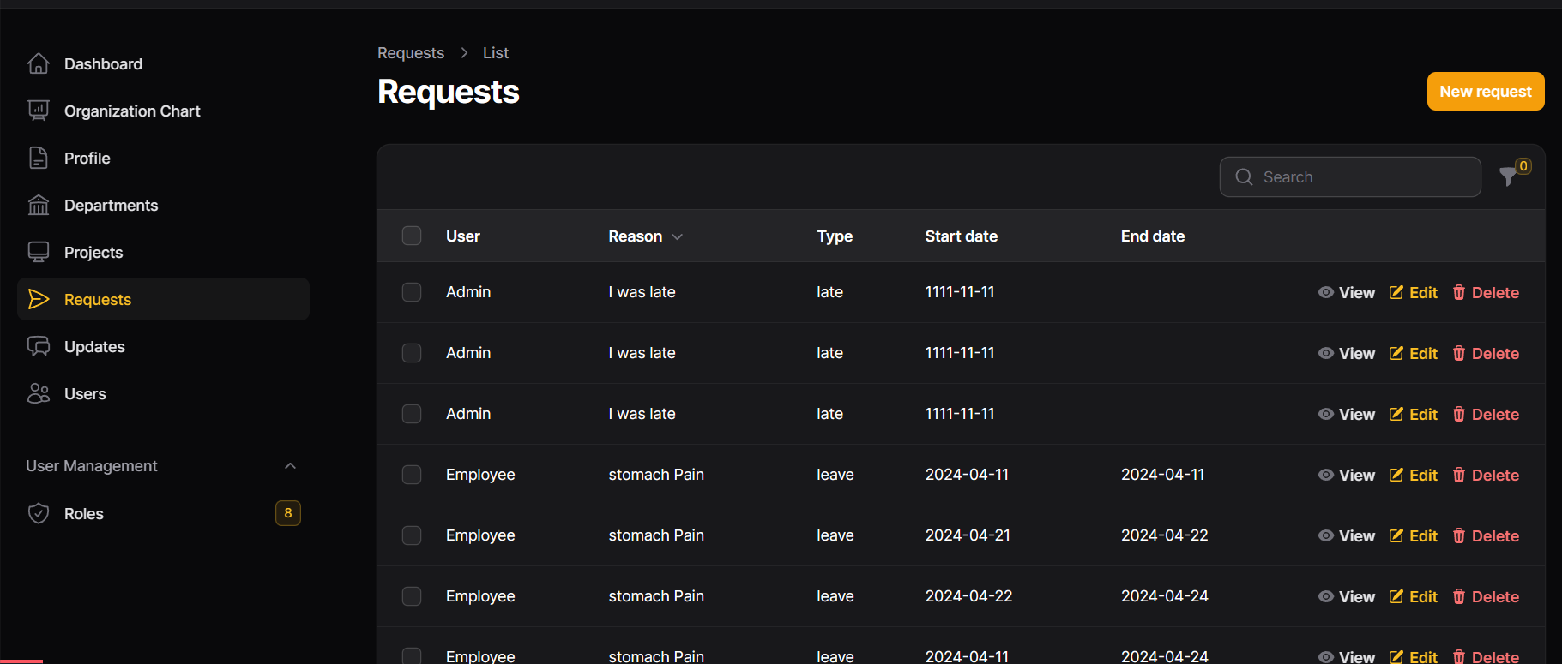

Figure 3: Showing system with no notification for request creation